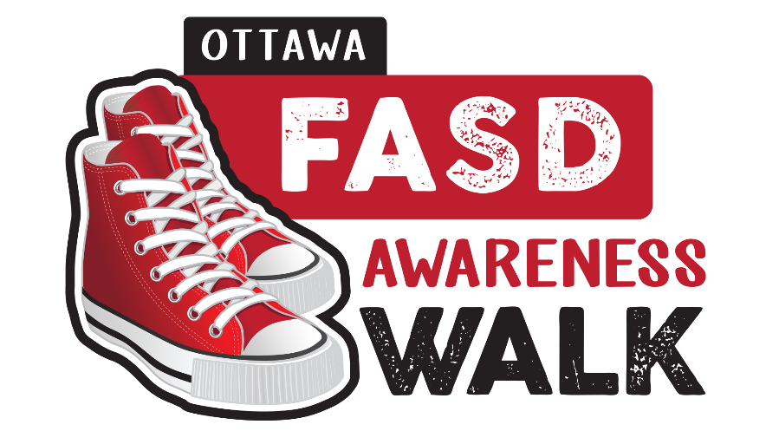

Sample Letter for FASD Participants/Supporters to send to Municipal Councillors, Provincial MPPs, and Federal MPs
Dear (insert name),
We know that you care about all the people in your (ward/riding), and we would love to have your support as we help to spread awareness of Fetal Alcohol Spectrum Disorder (FASD).
Please mark this important date in your calendar – September 11th. This is the date that the 4th annual FASD Awareness Walk will take place in downtown Ottawa. It begins at York Street Plaza and the 0.9 kilometre route finishes with a flag raising at Ottawa City Hall.
September 11th was chosen as it is the closest Saturday to the International FASD Awareness Day – which is observed on September 9th each year – the 9th day of the 9th month of the year, representing 9 months of pregnancy.
The FASD Awareness Walk is co-ordinated by ABLE2. We are walking to educate and inform people about the disorder, and that it can be prevented by avoiding alcohol consumption and having unprotected sex, which increases the potential to have an alcohol exposed pregnancy which can lead to FASD. This year we are celebrating those with lived experience – individuals with FASD and their parents/caregivers. More information about the Awareness Walk and FASD can be found on the ABLE2 website – https://www.able2.org/.
We would love to have your support in a variety of ways.
- Join families and friends of people with FASD, medical practitioners, caregivers, and local FASD program partners from Ottawa, Prescott Russell, and Stormont, Dundas & Glengarry for the walk on September 11.
- Encourage participation in the walk in your constituent calendars, newsletters, social media and website.
- Follow ABLE2’s social media posts on Twitter (@ABLE2Ott) and retweet them to your followers.
- If you can’t join us on the 11th, please wear red shoes on that day as an encouragement to those who will be walking.
FASD is often referred to as an invisible disability, and yet studies show that +/- 1.5 million Canadians are living with it today. Your encouragement to help us both support families and people with FASD, as well as working to encourage prevention would be invaluable.
We appreciate you have many demands on your time, but we would love to have you walk with us if your schedule permits. We all have a role to play in promoting alcohol-free pregnancies and supporting the 4% of your constituents with FASD (and their families).
Thank you for serving the people of our ward/riding, and please do not hesitate to contact me if you would like any additional information on FASD or the Awareness Walk.
Sincerely,

Your Name

